**Code of Conduct**

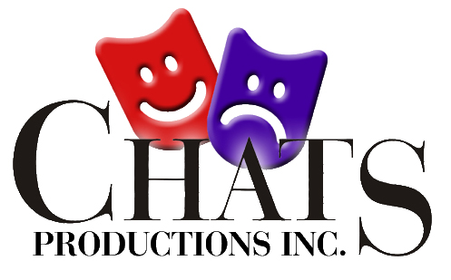

This Code of Conduct by Coffs Harbour Amateur Theatrical Society (CHATS Productions Inc) outlines our commitment to a person’s right to be treated with respect and dignity and to be safe and protected from abuse. It informs everyone involved in CHATS of their legal and ethical rights and responsibilities, and the standards of behaviour that are required.

The Code of Conduct is a set of guidelines/requirements that clarify the expectations of members, performers, production staff and all volunteers on how to conduct themselves whilst involved in the activities of the association. By following this Code of Conduct, your reputation, and the reputation of CHATS will be upheld and protected.

The Member’s code of conduct requires members to:

1. Treat all members and patrons with respect in all forms of communication, be it verbal, written or online and not to participate in disparaging commentary about others.
2. Support our anti-harassment policy and commitment to maintaining a theatre that is free of harassment, so members can feel safe.

Harassment, whether verbal, written or online email/text or tweet, includes bullying, intimidation, direct insults, malicious gossip and victimization. CHATS will not tolerate anyone being physically or verbally intimidating, violent, humiliating, or sabotaging others.

1. Not discriminate against members based on their race, religion, gender, ethnicity, sexual orientation or disability etc.
2. Not participate in behaviours that could be deemed as sexual harassment. Sexual harassment occurs when a person makes unwanted and/or repeated advances, including proximity, touching etc without consent.
3. Display control, respect, consideration and professionalism in all theatre- related activities. Be courteous when dealing with others.
4. Please be aware that some of our productions involve minors. CHATS encourages cast and crew camaraderie but asks you use appropriate language and behaviour around minors.
5. No cast member is to be front of house prior to or during a performance,

or to appear in costume or makeup outside of the stage or dressing rooms area without the permission of the Stage Manager.

1. All visitors and family are not allowed backstage until after the performance is completed.
2. There is to be no smoking or drinking of alcohol in any backstage area or in the lighting box.
3. The Stage Manager is responsible for the running of a performance from the commencement of the final dress rehearsal.
4. The Director shall only be allowed to speak to the cast or crew prior to or during a performance with the permission of the Stage Manager.
5. The Front of House Manager has full control of Front of House activities after commencement of the opening performance.
6. Refrain from any behaviour that will bring CHATS into disrepute.

**Complaints Procedure**

If you have an issue or a complaint CHATS encourages you to do something about it. Please refer to our complaints resolution procedure which you’ll find in the CHATS Constitution under the Member Protection Policy. This Member Protection Policy supports the Code of Conduct and aims to provide a safe, fun and fair environment to work and perform in.

The policy makes clear the behaviour CHATS wishes to promote as well as the behaviour considered to be unacceptable. It also outlines a comprehensive informal and formal complaints resolution procedure.

Any Infringement of the Code of Conduct guidelines by a member can be brought by another member to either the show director, stage manager, president or any of the committee members.

**Breach of the Code of Conduct**

Disregard of any part of this Code of Conduct may jeopardise your membership and/or ability to work with CHATS.

The procedure for disciplining members breaching the Code of Conduct is covered in the CHATS Constitution Section 11, Points 1-6.

The Right of Appeal of a member is covered in the CHATS Constitution Section 12, Points 1-5.